|  |  |
| --- | --- |
|  | 🞂Student Registration System |
|  |  |
|  | Abdullah Alshehry🞂 🞂 4/27/2014 |
|  |  |
|  |  |
|  |  |
|  |  |
|  |  |
|  |  |
|  |  |
|  |  |
|  |  |
|  |  |
|  |  |
|  |  |
|  |  |
|  |  |
|  |  |
|  |  |
|  |  |
|  |  |
|  |  |
|  |  |
|  |  |
|  |  |
|  |  |
|  |  |
|  |  |
|  |  |
|  |  |
|  |  |
|  |  |
|  |  |

Student Registration System

#### Introduction:

The student registration system allows a user to enroll in various courses in a university.

#### Scope:

The scope of the project is academic. The users can be both students and university staff. Staff include both professors and students.

#### Requirements:

* Students are not allowed to register in a course for which the student does not have pre-requisite.
* Students cannot enroll in more than 18 credit hours in a semester.
* Records in Student, Professor, Employee, Pre-requisite tables are added, edited and deleted by only Registrar office staff.
* Professors and registrar office staff can register (and add/drop) any student in one or more course.
* A student can add/drop class for himself/herself.
* When student registers for a class, the record

is added to the Enroll table.

#### Architecture/Design :

The database has following tables:

Class (class schedule) – schedule of classes for students to choose when registering.

Course – course catalog with course pre-requisites

Student

Professor

Department (department in which a professor belongs))

Employee

Enroll (student registration data are saved in this table)

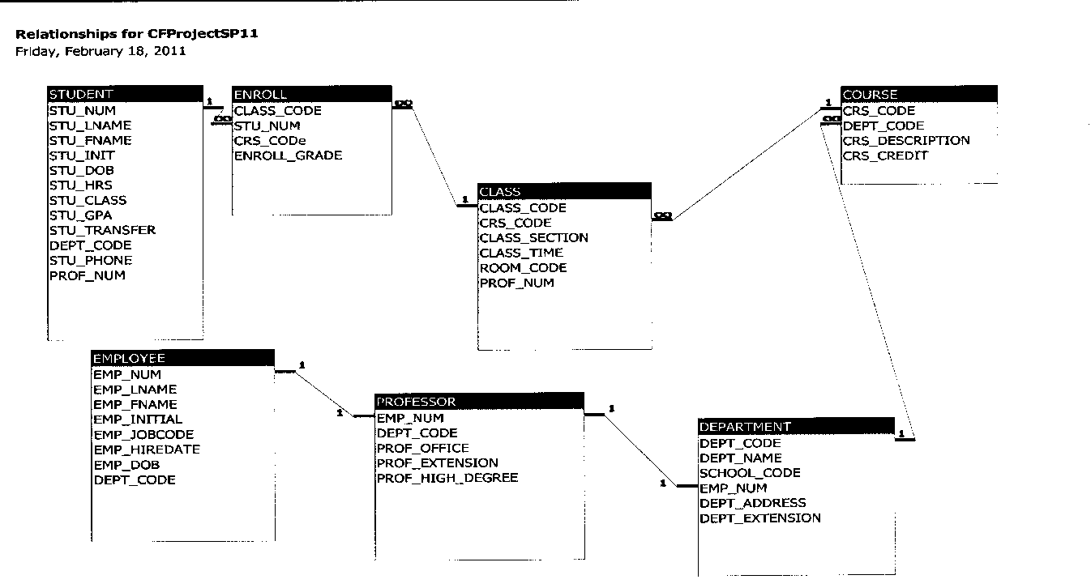

#### Technical Speculations:

##### Technologies used:

* + ColdFusion 9 Developer Edition
  + Microsoft Access db
  + HTML, CSS

##### Screens:

1. Main menu displaying options (Add, Edit, Delete, Search) for the user to select

2 Add sub-menu to add records in tables.

3. Edit sub-menu to modify records in tables.

4. Delete sub-menu to delete records in tables.

5. Search sub-menu to search records in tables

##### File structure:

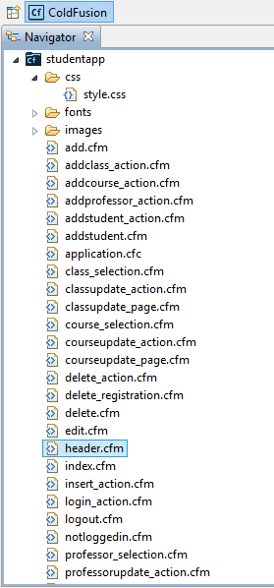

##### Use case diagram :

Figure 1student





Figure 2 staff